ROMA
A SYMPOSIUM

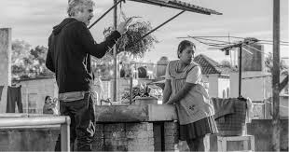

FRIDAY, MARCH 8, 2-4 PM
6020 HSSB

Eloi Grasset Morell
Kate Bruhn
Víctor Fuentes
Ellen McCracken
Mario T. García

Join faculty from the Departments of Chicana/o Studies, Spanish and Portuguese, and Political Science for a discussion of Alfonso Cuarón’s groundbreaking new film Roma.

Sponsored by the IHC Research Group on Latino Studies.

Free and open to the public

